Name: ​ ​ Date: ​
​
🐶​ Who Has What?
​
The Rule: Have Got vs. Has Got 🧠​

🧠​ | Remember:  - He / She / It (the animal) → has got  - I / You / We / They → have got
​
Part 1: Match the Animals 🐾​
​
Draw a line to match the animal to its correct body part.

Animal Name | Body Part
1. The Cat has got...  a-) ears  b-) a tail  c-) legs | 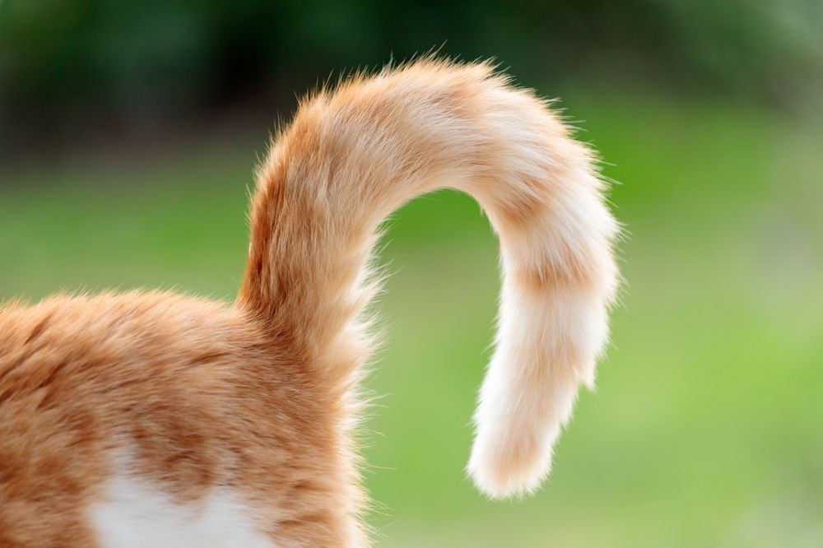
2. The Rabbit has got... | 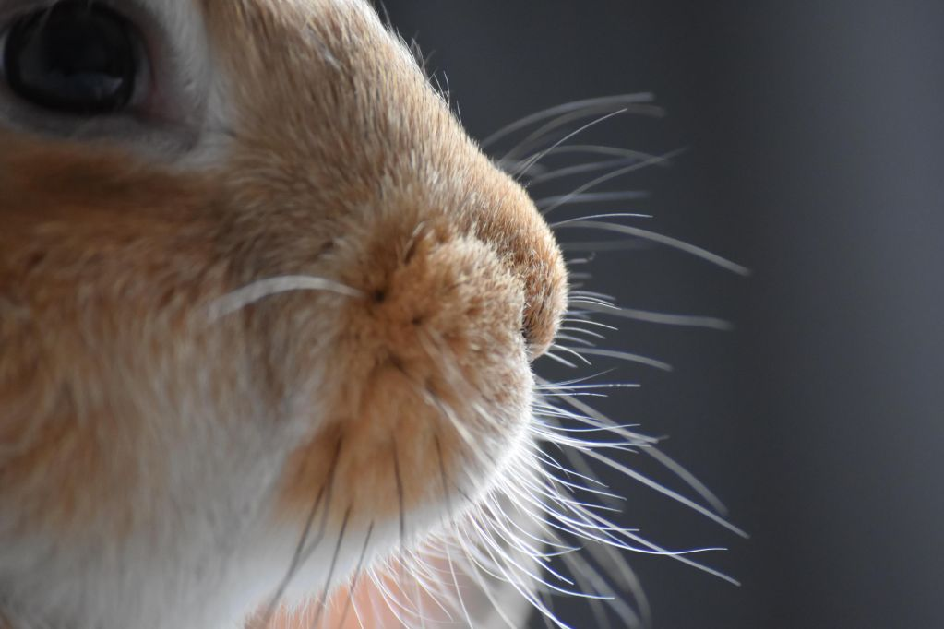

1. The Dog has got... | 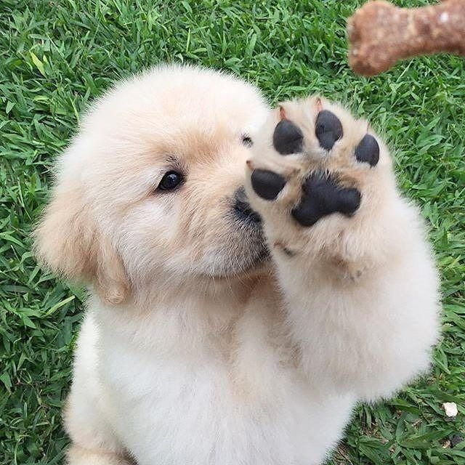
​
Part 2: Write Sentences ✏️​
​
Look at the picture. Choose the correct body part from the Word Bank. Write a full sentence using has got.

Example: The cat + whiskers → The cat has got whiskers.

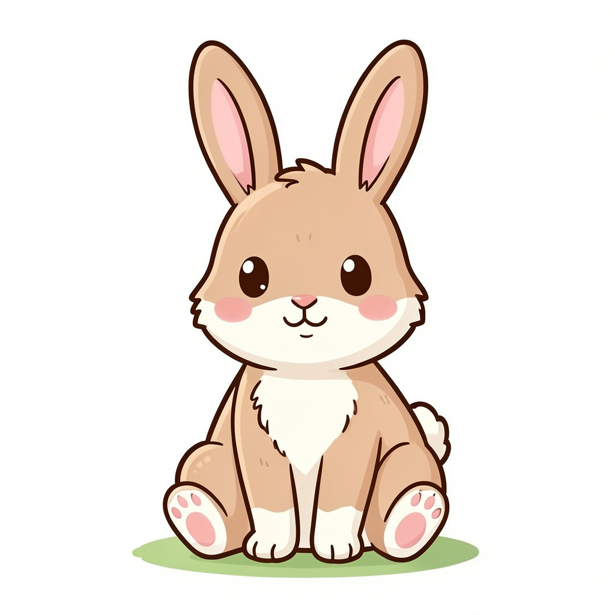 | 1. The Rabbit  Word Bank: ( long ears / wings )

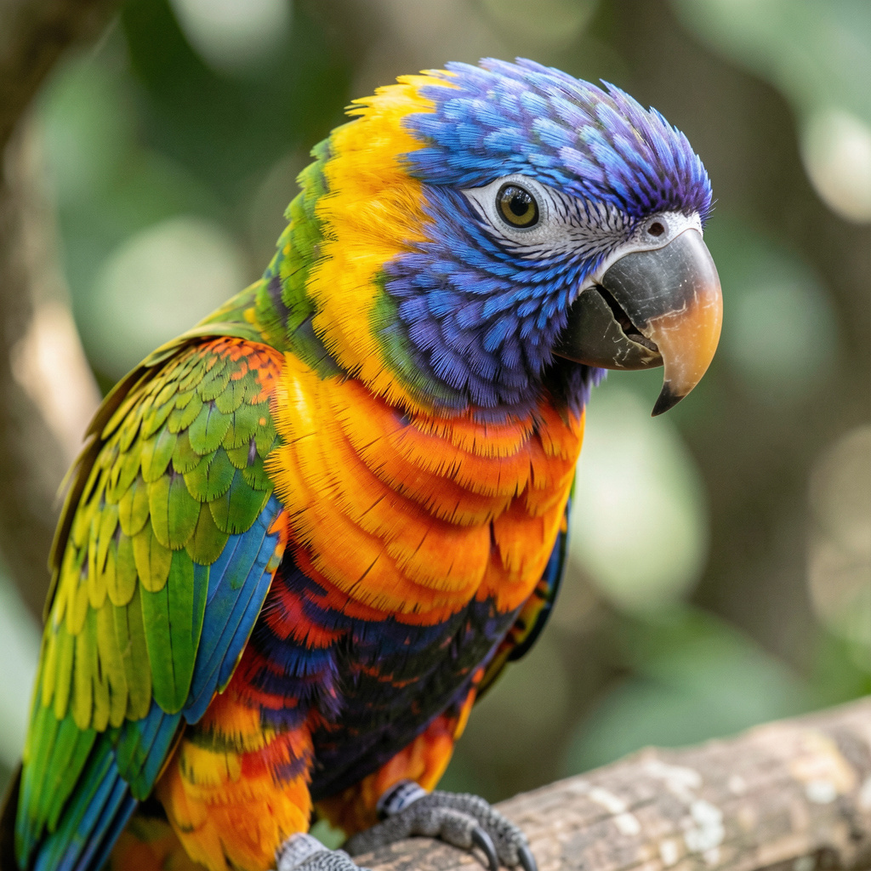 | 2. The Bird  Word Bank: ( paws / a small beak )

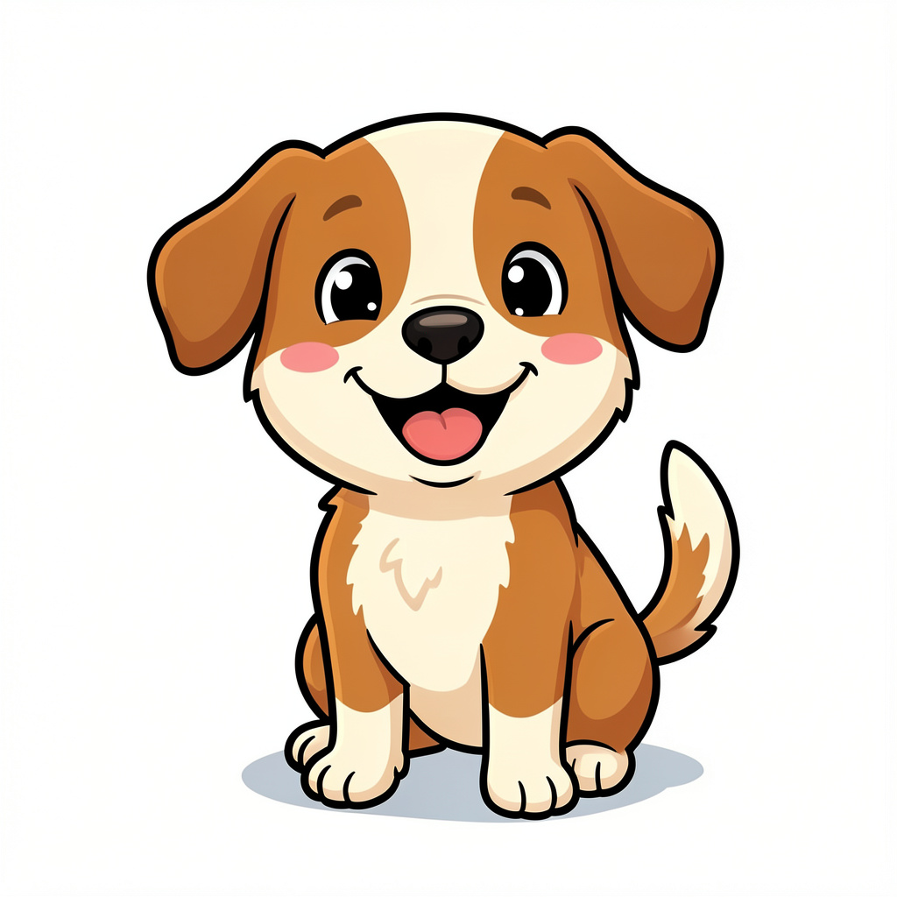 | 3. The Dog  Word Bank: ( floppy ears / fins )
​
Part 3: Draw Your Dream Pet 🎨​
​
Draw a funny or magical pet! Does it have 5 legs? Does it have wings?

Then write one sentence about it using It has got...

​
Part 4: Choose the Correct Answer ✅​
​
Read each sentence carefully. Choose the best answer to complete the sentence or identify the correct body part.

1. | Which sentence uses "has got" correctly? | a) I has got a rabbit.  b) She has got a lizard.  c) We has got two cats.  d) They has got long ears.

1. | Complete the sentence: "I __________ a goldfish." | a) has got  b) is got  c) have got  d) are got
2. | What has a bird got to help it fly? | a) Floppy ears  b) A wagging tail  c) Colorful wings  d) A white tail
3. | Which word belongs in the blank? "The rabbit __________ long ears." | a) have  b) has  c) am  d) are
4. | Choose the correct sentence: | a) The dog has got a wagging tail.  b) The dog have got a wagging tail.  c) The dog is got a wagging tail.  d) The dog are got a wagging tail.
Answer Key
​
Part 1: Match the Animals 🐾​
​
Image Matching:
Answer Key: 1-B, 2-C, 3-A
​
Part 2: Write Sentences ✏️​
​
Answer:
The rabbit has got long ears.
​
Answer:
The bird has got a small beak.
​
Answer:
The dog has got floppy ears.
​
Part 3: Draw Your Dream Pet 🎨​
​
Answer:
Answers will vary.
​
Part 4: Choose the Correct Answer ✅​
​
Multiple Choice:
1. She has got a lizard. (We use 'has got' for he, she, and it).
2. have got
3. Colorful wings
4. has
5. The dog has got a wagging tail. (The dog is an 'it', so we use 'has got').

